# {LOGO / if applicable}

**Cover Page**

**{Proposal Title}**

## {Proposal Acronym}

### SECURED Service Selected [ID]:1. Secure Multiparty Computation (SMPC), 3. Advanced Anonymization (AA)

| **Partner No** | **Partner full name** | **Abbr** | **Country** |
| --- | --- | --- | --- |
| 1 (Coordinator) |  |  |  |
| 2 |  |  |  |

# 

# Table of Contents

**Table of Contents 2**

General Information3

1. Concept 4

2. Impact4

3. Implementation 6

4. Consortium 7

5. Resources8

6. Ethics and security 9

# 

# 0. General Information

### Identity

| **Topic** | **Answer** |
| --- | --- |
| SECURED Service Selected [ID(s)] | (e.g., )  1. Secure Multiparty Computation (SMPC)  3. Advanced Anonymization (AA) |
| Acronym | (e.g., PRIV-HEALTH) |
| Title | (e.g., Privacy-Preserving AI Analytics for Secure Health Data Collaboration) |
| Abstract | This is a summary of the proposal that will not be made public. |

### Public summary

| max = 2,000 characters (with spaces) |
| --- |

# 

# 1. Concept

Length: (suggested) 2 A4 pages

Describe the overall concept and objectives of the project, ensuring alignment with the scope of the SECURED Open Call. Address the challenge proposed by SECURED and include the following elements:

* The specific healthcare scenario and proposed solution(s), highlighting the integration of SECURED services and components (see Annex 1.1)
* The technical challenges and barriers that the project aims to solve
* The expected outcomes, ensuring they are justified, measurable, and realistic within the project timeline
* The innovation potential, emphasizing how the project is novel and contributes to secure data analytics in the healthcare sector
* The Technology Readiness Level (TRL) of the proposed solution
* What kind of resources of SECURED services and components do you intend to use and how?
* Which pre-existing software/hardware/solution do you plan to bring to “the project” and use (integration)?

# 2. Impact

Length: (suggested) 2 A4 pages

* Socio-Economic Impact
  + Describe the relevance, socio-economic impact, and benefits of the project, including its relevance to healthcare data privacy and secure multiparty computation
  + Highlight the project's industrial relevance and market potential
  + Outline its contribution to data privacy and the advancement of privacy-enhancing technologies within healthcare analytics
* Commercialization and Business Strategy
  + Describe the commercialization strategy and planned activities during and after the project to ensure sustainability and impact
  + Include any promotional activities that are planned to raise awareness of the project's solutions
  + Elaborate on benefits intended to be achieved. If possible, quantify these benefits (e.g., process / solution innovation / cost savings / time reduction / job creation / other)
  + Elaborate on the market is the resulting product positioned (e.g., market size, your market share, expected growth of your market share considering the advantages will be achieved in a period of 1 to 5 years)
  + Elaborate on potential adjacent market segments that you want to address with the results of this experiment in a similar way.

|  | **KPI Metrics** | | | | |
| --- | --- | --- | --- | --- | --- |
| Partner Abbr | Year after experiment | KPI Name/Description | Measurement Methodology, Data Sources | Baseline Value | Target Value |
| Partner 1 | 1 |  |  |  |  |
| 2 |  |  |  |  |
| Partner 2 | 2 |  |  |  |  |
| 3 |  |  |  |  |
| All | 1 |  |  |  |  |
| 2 |  |  |  |  |

**In case of a Consortium:** Please complete the following table for each partner in the consortium individually.

# 3. Implementation

Length: (suggested) 3-4 A4 pages

Describe the proposed **experiment** and the **work plan** for achieving the objectives and results. Include the following:

* **Specific activities** to be implemented, the time required, and the expected outputs
* Relevant **milestones** and **KPIs** to measure progress and success
* How the **experiment** will be demonstrated and validated using SECURED services
* An outline of **external risks** that may affect the work plan

**Table 1**: Suggested format for describing activities

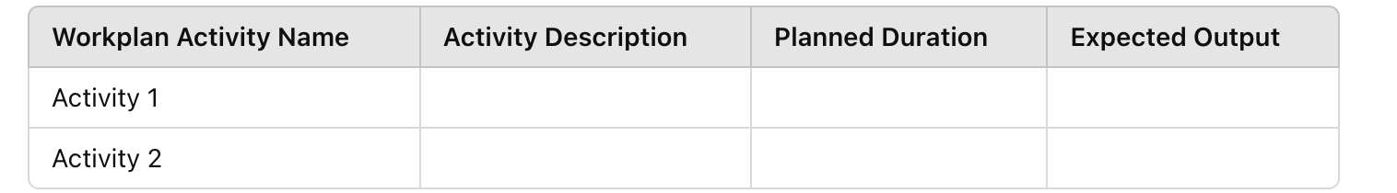

**Table 2**: Suggested format for describing milestones

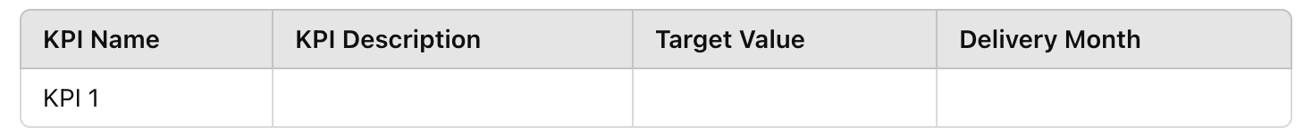

There is one mandatory activitiy:

* to monitor progress and results by writing a final report and attending and contributing to the relevant project review meeting as organized by the SECURED project

Suggestions for activities:

* collect technical and usability requirements (typically run in the first 1 month);
* design and analyse suitable business model(s) for the commercial exploitation of the results (typically accompanies the full duration);
* evaluate the outcomes (typically run in the last 1 month).

## 

# 4. Consortium

Length: (suggested) 1-2 A4 pages

Provide the core consortium structure in the table below, including the names of individuals associated with each partner. The individuals listed in the proposal must be later involved in the execution of the project. While it is acceptable to involve additional team members in project implementation who are not identified in the proposal, the core team outlined below must remain intact.

Additionally, provide a detailed overview of the consortium, listing all partners and their respective roles. Include the following:

* Names of the **core team** members along with a brief summary of their expertise.
* A description of each team member's **experience** in relevant fields (e.g., previous projects, publications, etc.).
* A justification of how the consortium's **structure, expertise, and gender balance** contribute to the project’s success.

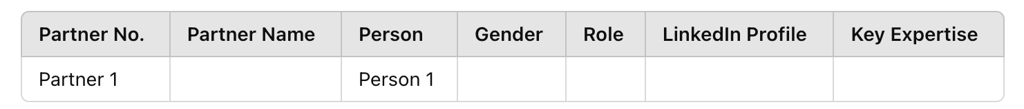

## 

# 5. Resources

Length: (suggested) 1-2 A4 pages

Provide the number of **person-months** (full-time equivalent) for each partner involved in the project for the duration (**up to 6 months**) of the project.

**Table 4**: Person-months allocated to the project

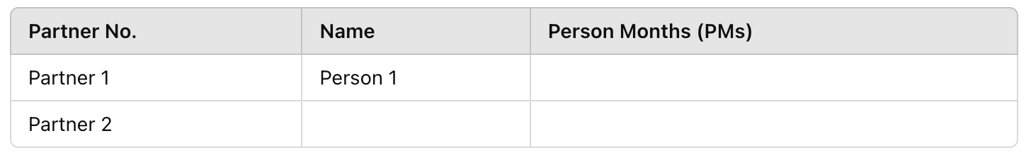

Provide a detailed description of expected costs and requested funding using the following table:

**Table 5**: Breakdown of costs.

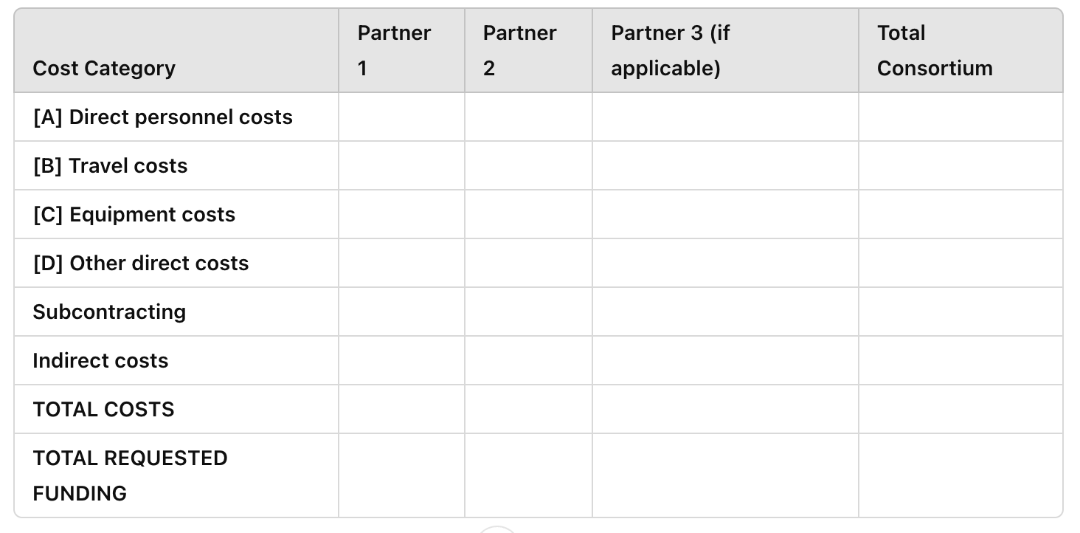

## 

# 6. Ethics and security

Length: (suggested) 1-2 A4 pages

For the SECURED Project, if you have identified any ethical issues in the **Ethical Issues Table**, you must take the following steps:

1. **Submit an Ethics Self-Assessment**, which includes the following components:
   * **National Legal and Ethical Requirements**: Describe how the proposal complies with the national legal and ethical requirements of the country or countries where the tasks that raise ethical issues will be conducted
   * **Detailed Ethical Issue Mitigation**: Explain in detail how you plan to address the identified ethical issues from the table. Specifically, this should cover:
     + **Research Objectives**: Outline the ethical considerations related to research objectives, such as the study of vulnerable populations, potential dual-use technologies, or other sensitive topics.
     + **Research Methodology:** Address the methodology and any ethical safeguards, including consent procedures for participants (e.g., involvement of children or vulnerable populations, clinical trials, and the protection of personal data).
     + **Potential Impact:** Consider the broader impact of the research, including risks of dual-use, environmental harm, stigmatization of social groups, political or financial retaliation, benefit-sharing, or the malevolent use of research outcomes.
2. **Provide Required Documents** under national law, if applicable:
   * **Ethics Committee Opinion**: A document from the relevant ethics committee or board approving the research.
   * **Authorization or Notification Documents**: Any official documents that notify or authorize activities raising ethical concerns.

If these documents are **not in English**, include an **English summary** of the documents. The summary should include the conclusions of the ethics committee or authority, where available.

1. **Future Requests**:
   * If the required documents will need to be requested specifically for the project, the request must include an explicit reference to the **SECURED Project** title.
2. Complete the **Ethics/Security** Annex (Ethics/Security Checklist). Address all relevant ethical and security concerns associated with the project. This ethics self-assessment is crucial to ensure that your proposal complies with both national and international ethical standards, particularly in the fields of healthcare and secure data analytics.

**Ethical Issues Table:** Answer "YES" or "NO" for each question.

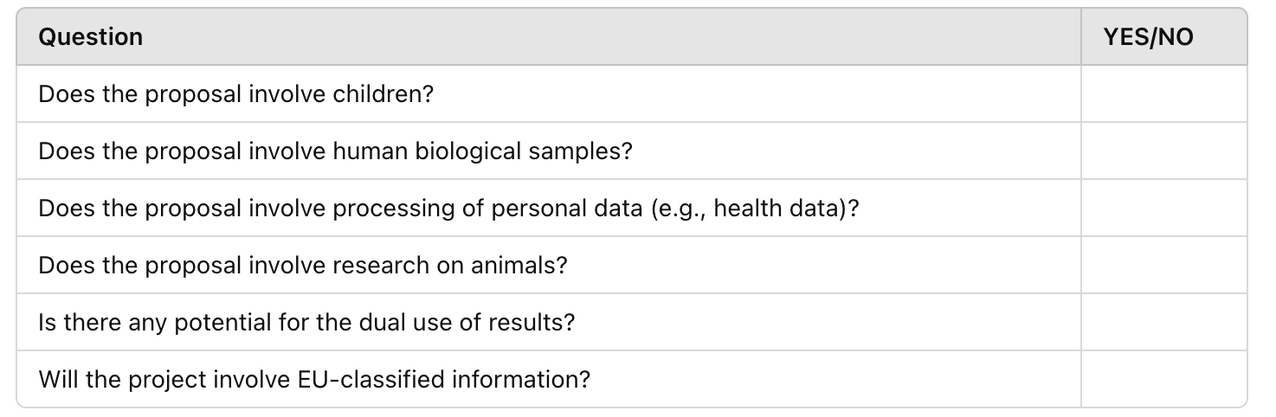

I confirm that none of the above issues apply to my proposal: [YES/NO].